SKILL 11,12 & 13:
11. To Store Commands, Maintain History Buffer, Handle Capacity Limits, Retrieve Entries, Display History, Validate Consistency.

To Create Pipeline Structures, Store Commands, Maintain Execution Order, Connect Processes, Validate Pipeline Layout, Test Configurations.

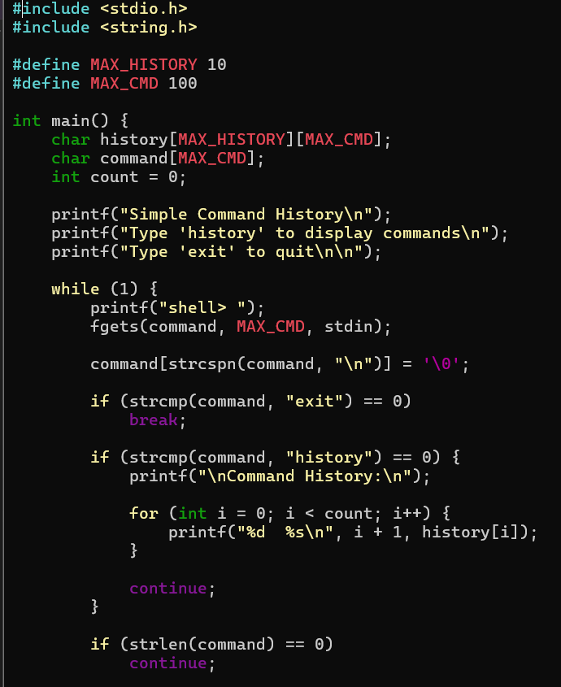

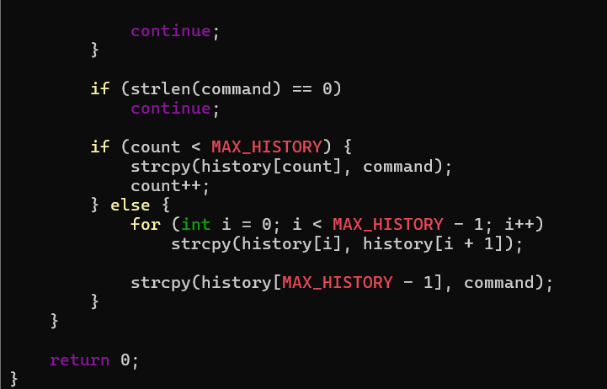

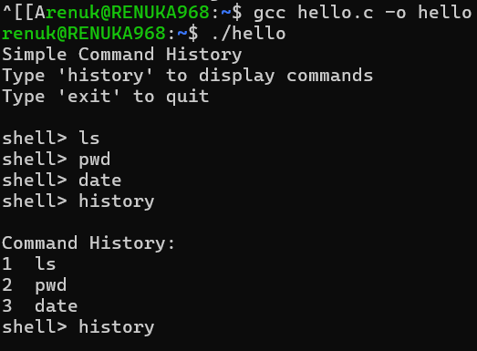

12. To Create Pipes, Redirect Streams, Execute Connected Commands, Close Descriptors, Synchronize Processes, Test Data Flow.

To Support Multiple Pipes, Manage Descriptor Arrays, Launch Multiple Processes, Coordinate Execution, Cleanup Resources, Test Long Pipelines.

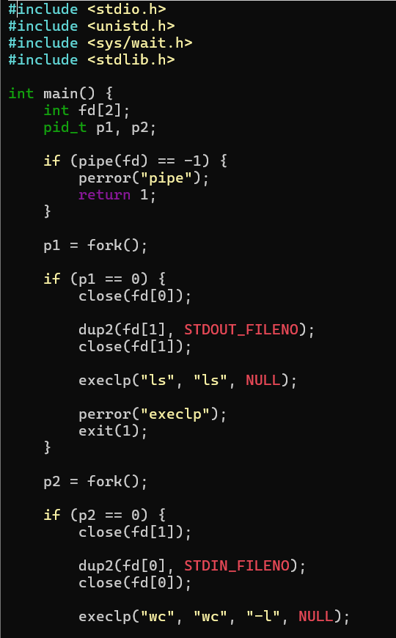
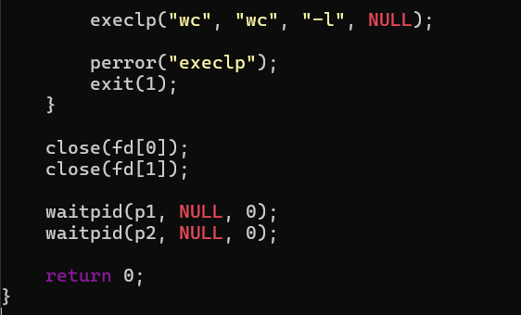

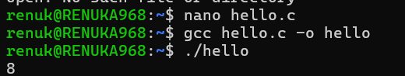

13. To Parse Input Redirection, Open Files, Redirect stdin, Handle Missing Files, Restore Streams, Test File Inputs.

To Parse Output Redirection, Create Output Files, Redirect stdout, Handle Permissions, Verify Output Data, Test Redirection.

